27.11: a) Wb.
b) Wb.
c) 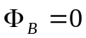since 